**2.3.1 Comparison of OFDMA with Packet-Oriented Protocols**

Like 3GPP LTE, IEEE 802.11a uses OFDM as the underlying modulation method. However, 802.11a uses CSMA as the multiplexing method. CSMA is essentially a listen-before-talk scheme. For example, when the AP has queued traffic for a STA, it monitors the channel for activity. When the channel becomes idle, it begins to decrement an internal timer that is randomized within a specified window. The timer will continue to be decremented as long as the network remains idle. When the timer reaches zero, the AP will transmit a PHY layer packet of up to 2000 bytes addressed to a particular STA (or all STAs within the cell in the case of broadcast mode). The randomized back-off period is designed to minimize collisions, but it cannot eliminate them entirely.

Each 802.11a PHY packet utilizes all of the PHY layer bandwidth for the duration of the packet. Consider the 802.11a PHY packet format shown in Figure 2.3.1-1. Each 802.11a packet has a data payload of varying length from 64 to 2048 bytes. If the packet transmission is successful, the receiving station transmits an ACK. Unacknowledged packets are assumed to be dropped. Note that each packet is preceded by a PHY preamble which is 20 μsec in duration. The purposes of the PHY preamble are: • Signal detection • Antenna diversity selection• Setting AGC • Frequency offset estimation • Timing synchronization • Channel estimation

The address of the intended recipient is not in the PHY preamble. It is actually in the packet data and is interpreted at the MAC layer. From a networking perspective, the packet-oriented approach of 802.11a has the advantage of **simplicity**. Each packet is addressed to a single recipient (broadcast mode not withstanding). However, the randomized backoff period of the CSMA multiplexing scheme is idle time and therefore represents an **inefficiency**. The PHY preamble is also network overhead and further reduces efficiency, particularly for shorter packets.

The typical real-world efficiency of an 802.11a system is approximately **50 percent**. In other words, for a network with a nominal data rate of 54 Mbps, the typical throughput is about 25 – 30 Mbps. Some of the inefficiencies can be mitigated by abandoning the CSMA multiplexing scheme and adopting a scheduled approach to packet transmission. Indeed, subsequent versions of the 802.11 protocol include this feature. Inefficiencies due to dedicated ACK packets can also be reduced by acknowledging packets in groups rather than individually.

In spite of potential improvements, it remains difficult to drive packet-oriented network efficiency much beyond 65 to 70 percent. Further, because each packet completely consumes all network resources during transmission and acknowledgement, the AP can provide addressed (non-broadcast) traffic to user terminals only on a sequential basis. When many users are active within the cell, **latency** can become a significant problem. Clearly, the objective of cellular carriers is to create as much network demand as possible for a wide variety of traffic that includes voice, multimedia, and data. Efficiency and low latency are therefore paramount. As we will see in the following section, OFDMA is superior to packet-oriented schemes in both of these critical dimensions.

**2.3.2 OFDMA and the LTE Generic Frame Structure**

OFDMA is an excellent choice of multiplexing scheme for the 3GPP LTE downlink. Although it involves added complexity in terms of resource scheduling, it is vastly superior to packet-oriented approaches in terms of **efficiency** and **latency**. In OFDMA, users are allocated a specific number of subcarriers for a predetermined amount of time. These are referred to as **physical resource blocks (PRBs)** in the LTE specifications. PRBs thus have both a time and frequency dimension. Allocation of PRBs is handled by a scheduling function at the 3GPP base station (eNodeB).

In order to adequately explain OFDMA within the context of the LTE, we must study the PHY layer generic frame structure. The generic frame structure is used with FDD. Alternative frame structures are defined for use with TDD. However, TDD is beyond the scope of this paper. Alternative frame structures are therefore not considered.

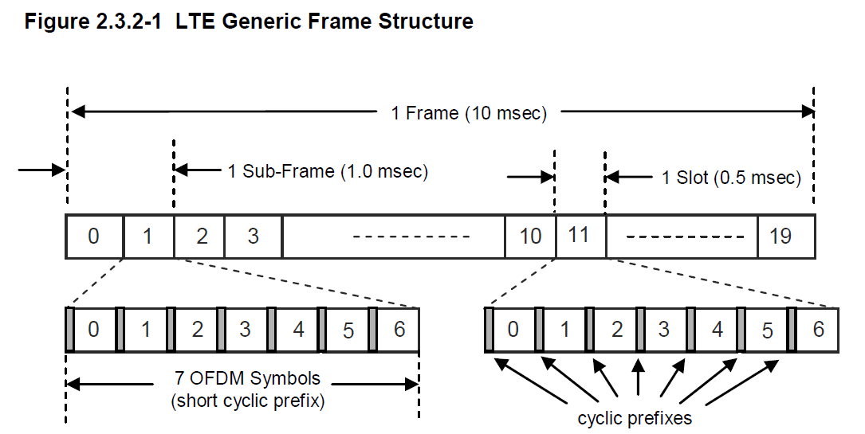

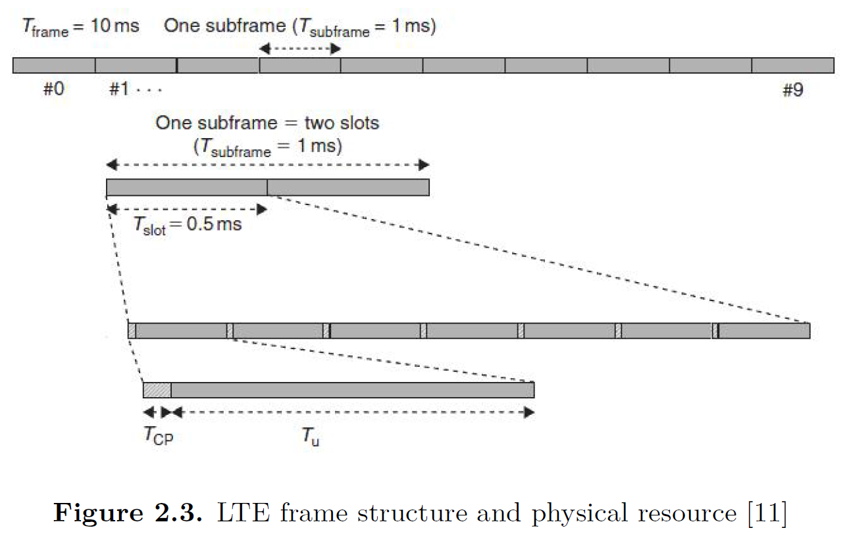

As shown in figure 2.3.2-1, **LTE frames** are **10 msec** in duration. They are divided into **10 subframes**, each subframe being **1.0 msec** long. Each subframe is further divided into **two slots**, each of **0.5 msec** duration. Slots consist of either **6 or 7 ODFM symbols**, depending on whether the normal or extended cyclic prefix is employed.

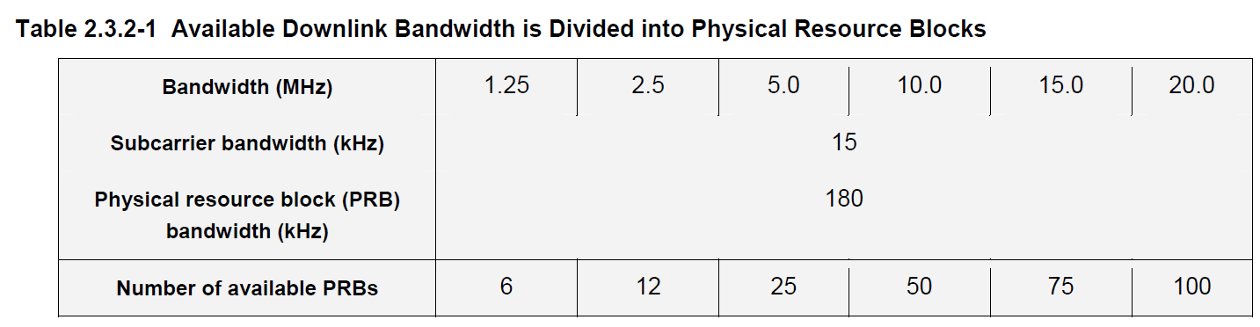

The total number of available subcarriers depends on the overall transmission bandwidth of the system. The LTE specifications define parameters for system bandwidths from 1.25 MHz to 20 MHz as shown in Table 2.3.2-1. A **PRB** is defined as consisting of **12 consecutive subcarriers for one slot (0.5 msec)** in duration

BW/subcarrier = 15 KHz, Subcarriers/PRB = 12, BW/PRB = 15 x 12 = 180 KHz

Total BW = 1.25MHz => Total PRBs = 1.25x1000/180 = 6.94 ~ 6

Total BW = 2.5MHz => Total PRBs = 2.5x1000/180 = 13.88 ~ 12

Total BW = 5.0MHz => Total PRBs = 5.0x1000/180 = 27.76 ~ 25

…

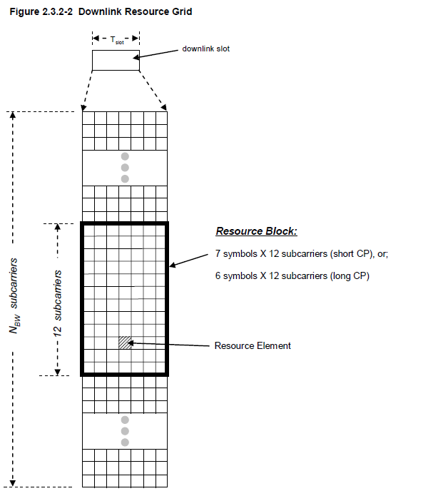

The transmitted downlink signal consists of NBW subcarriers for a duration of Nsymb OFDM symbols. It can be represented by a resource grid as depicted in Figure 2.3.2-2. Each box within the grid represents a single subcarrier for one symbol period and is referred to as a **resource element** (RE). Note that in MIMO applications, there is a resource grid for each transmitting antenna.

In contrast to packet-oriented networks, LTE does not employ a PHY preamble to facilitate carrier offset estimate, channel estimation, timing synchronization etc. Instead, special reference signals are embedded in the PRBs as shown in Figure 2.3.2-3. Reference signals are transmitted during the first and fifth OFDM symbols of each slot when the short CP is used and during the first and fourth OFDM symbols when the long CP is used.

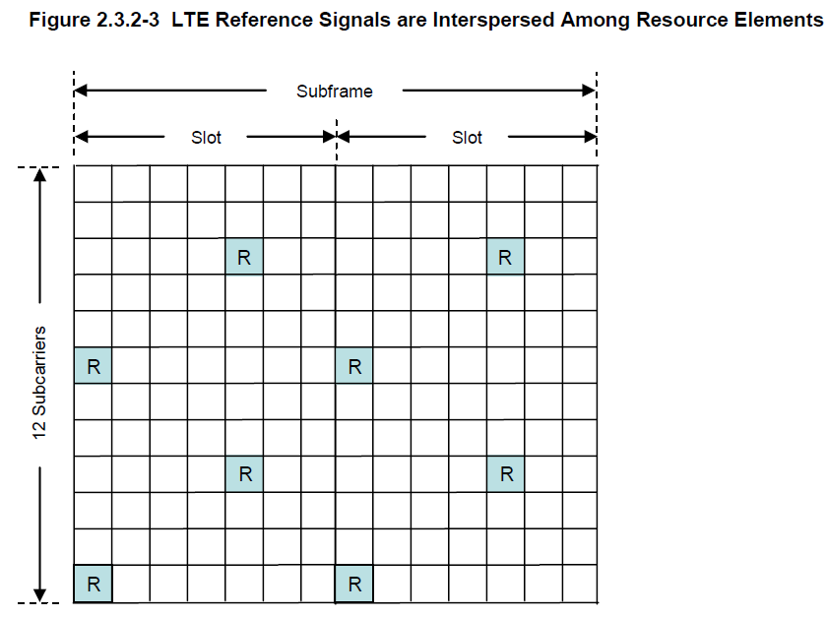

Note that reference symbols are transmitted every sixth subcarrier. Further, reference symbols are staggered in both time and frequency. The channel response on subcarriers bearing the reference symbols can be computed directly. Interpolation is used to estimate the channel response on the remaining subcarriers.

**Transmission time interval (TTI) = 2 slots = 1 ms**

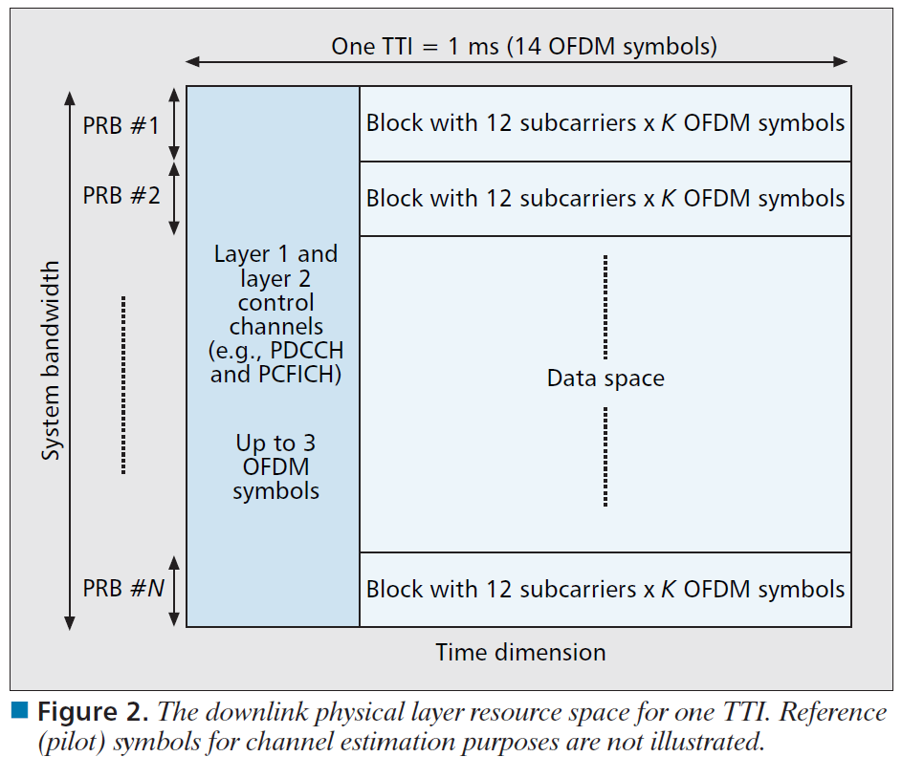

short cyclic prefix => 7 symbols/slot

14 symbols/TTI

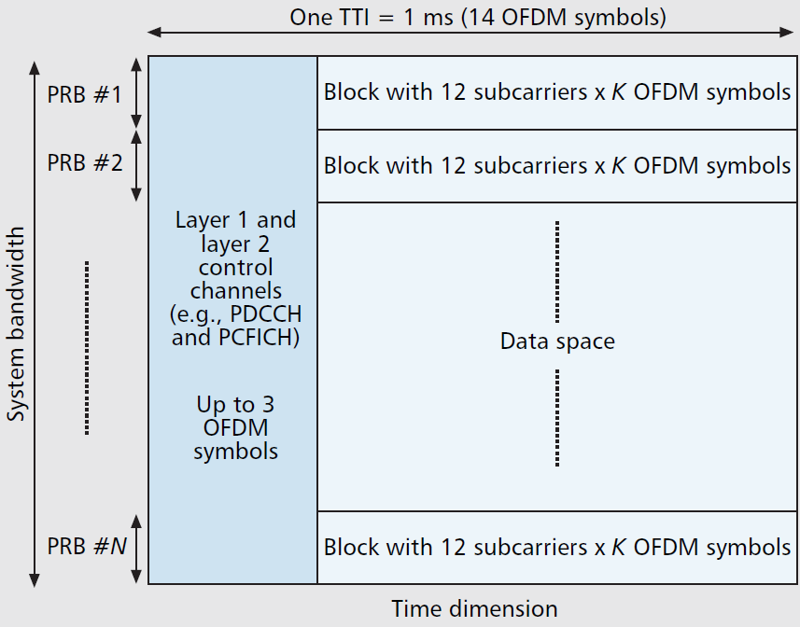

**The smallest resource unit assigned to a given user is Scheduling Block - SB (12 subcarriers x 1 ms) or RB (12 subcarriers x 0.5 ms)? => SB (12 subcarrier x 1 ms)? YES**

**Why need the concept of frame = 10 TTI’s?**

LTE FDD Radio Frame structure :-

In time domain :  
1) 10 ms long with 10 subframes each of 1 ms.  
2) Each subframe has two slots of 0.5 ms each & each slot has 7 orthogonal symbols.

1 frame (10ms) = 10 x sub-frames (1 ms)

1 sub-frame (1 ms) = 2 x slots (0.5 ms)

In freq domain :  
1) 72 subcarriers each of 15KHz bandwidth & grouped into 6 RBs (PRBs).

Collectively:  
1) An entity consisting of a subframe (1ms) of time domain & 12 subcarriers is known as **Scheduling Block (SB).**  
2) An entity consisting of a slot (0.5ms) of time domain & 12 subcarriers is known as **Resource Block (RB).**  
3) An entity consisting of a orthogonal symbol (0.071428 ms) & one subcarrier (15khz) is known as **Resource Element (RE).**

1 RE = 1 (carrier) x 1 (symbol)

**1 RB = 12 (sub-carriers) x (6 or 7) (symbols) RE’s**

1 SB = 2 (time slots) x RB

Total BW = 20 MHz => 100 PRBs within 1 time slot (0.5 ms)

So a LTE radio frame consists of 10 subframes (i.e. total 1 ms) in time domain & 72 subcarriers (i.e. total 1080 Khz) in freq domain.

Why 15kHz? It is because UMTS and LTE have the same clock timing!  
I’ll explain it with an example.  
In LTE for BW=5MHz, there is 300 subcarrier. (with 10% guard band, 4.5MHz/15KHz=300)  
But we know that in IFFT/FFT transformation, Nfft should be a power of 2 (to speed-up the FFT operation). 300 is not a power of 2 and the next power of two is 512.  
Fs = Nfft x Δf (because Fs=1/Ts , Ts=Tsym/Nfft and Δf=1/Tsym=15kHz)  
For BW=5MHz, Fs=512*15kHz=7.68MHz => Fs=2*3.84MHz  
(3.84MHz is chip rate in UMTS).

We could reach to our timing goals by sub-carrier spacing equal to 7.5KHz or 30KHz also, but 15KHz is an agreement base on multicarrier transmission challenges (ISI , Doppler effect, …).

Why 12 sub-carriers is there in a RB? I think if we notice to total subcarrier in different LTE Bandwidth we can guess the answer. 20MHz->1200subcarrier, 15MHz->900, 10MHZ->600, 5MHz->300, 3MHz->180, 1.4MHZ->84 (with 10% guard band for all), 12 is the greatest common divisor of them.

Why 7 “**Time slots” (symbols?)** for a RB?  
We know that RB is the smallest block that is allocated to an UE in LTE. I think RB Time slots number’s value is an agreement base on latency (.5mSec for a RB) and traffic efficiency (84symbol/.5msec). (84 is equal to 12 subcarrier*7 Recourse Elements). In wimax (IEEE 802.16d), block size is not fixed.

<http://www.eetimes.com/document.asp?doc_id=1278199>

*Transport Channels*

1- Physical Broadcast Channel (PBCH): The PBCH broadcasts a limited number of parameters essential for initial access of the cell such as downlink system bandwidth, the Physical Hybrid ARQ Indicator Channel structure, and the most significant eight-bits of the System Frame Number. These parameters are carried in what's called a **Master Information Block** **(MIB)** which is 14 bits long.

The PBCH is designed to be detectable without prior knowledge of system bandwidth and to be accessible at the cell edge. The MIB is coded at a very low coding rate and mapped to the **72 center sub-carriers (6 RBs) of the OFDM structure**. PBCH transmission is **spread over four 10 ms frames** (over subframe #0) to span a **40 ms** period. Each subframe is self decodable which reduces latency and UE battery drain in case of good signal quality, otherwise, the UE would 'soft-combine' multiple transmissions until the PBCH is decoded. The PBCH is transmitted using Space Frequency Block Code (SFBC), a form of transmit diversity, in case of multiple antennas thereby allowing for greater coverage.

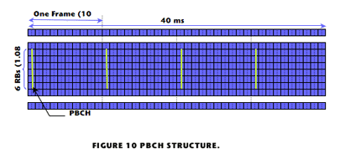

2- Physical Downlink Shared Channel (PDSCH): The PDSCH is the main data bearing channel which is allocated to users on a dynamic and opportunistic basis. The     PDSCH carries data in what's known as Transport Blocks (TB) which correspond to a MAC PDU. They are passed from the MAC layer to the PHY layer once per Transmission Time Interval (TTI) which is 1 ms (i.e. 1 ms scheduling interval to meet low latency requirements).

To guard against propagation channel errors, convolutional turbo coder is used for forward error correction. The data is mapped to spatial layers according to the type of multi-antenna technique (e.g. closed loop spatial multiplexing, open-loop, spatial multiplexing, transmit diversity, etc.) and then mapped to a modulation symbol which includes QPSK, 16 QAM and 64 QAM.

Physical resources are assigned on a basis on two resource blocks for one TTI (1 ms). This is referred to by 'pair of resource blocks' which is the quantum of resources that can be allocated. It corresponds to 12 sub-carriers (180 kHz) for 14 OFDM symbols (normal CP mode).

The PDCH is also used to transmit broadcast information not transmitted on the PBCH which include System Information Blocks (SIB) and paging messages.

3- Physical Multicast Channel (PMCH): This channel defines the physical layer structure to carry Multimedia Broadcast and Multicast Services (MBMS). However, MBMS are not included in the first release of LTE. The PMCH is designed for a single-frequency network and it requires that the base stations transmit with tight time synchronization the same modulated symbols. The PMCH is transmitted in specific dedicated subframes where the PDSCH is not transmitted.

***Control Channels***

Control occupy the first 1, 2, or 3 OFDM symbols in a subframe extending over the entire system bandwidth as shown in Error! Reference source not found.. In narrow band systems (less than 10 RBs), the control symbols can be increased to include the fourth OFDM symbol.

1- Physical Downlink Control Channel (PDCCH): The PDCCH carries the resource assignment for UEs which are contained in a Downlink Control Information (DCI) message. Multiple PDCCHs can be transmitted in the same subframe using Control Channel Elements (CCE) each of which is a nine set of four resource elements known as Resource Element Groups (REG). QPSK modulation is used for the PDCCH. Four QPSK symbols are mapped to each REG. Furthermore, 1, 2, 4, or 8 CCEs can be used for a UE depending on channel conditions to ensure sufficient robustness.

2- Physical Control Format Indicator Channel (PCFICH): This channel carries the Control Frame Indicator (CFI) which includes the number of OFDM symbols used for control channel transmission in each subframe (typically 1, 2, or 3). The 32-bit long CFI is mapped to 16 Resource Elements in the first OFDM symbol of each downlink frame using QPSK modulation.

3- Physical Hybrid ARQ Indicator Channel (PHICH): The PHICH carries the HARQ ACK/NAK which indicates to the UE whether the eNodeB correctly received uplink user data carried on the PUSCH. BPSK modulation is used with repetition factor of 3 for robustness.

